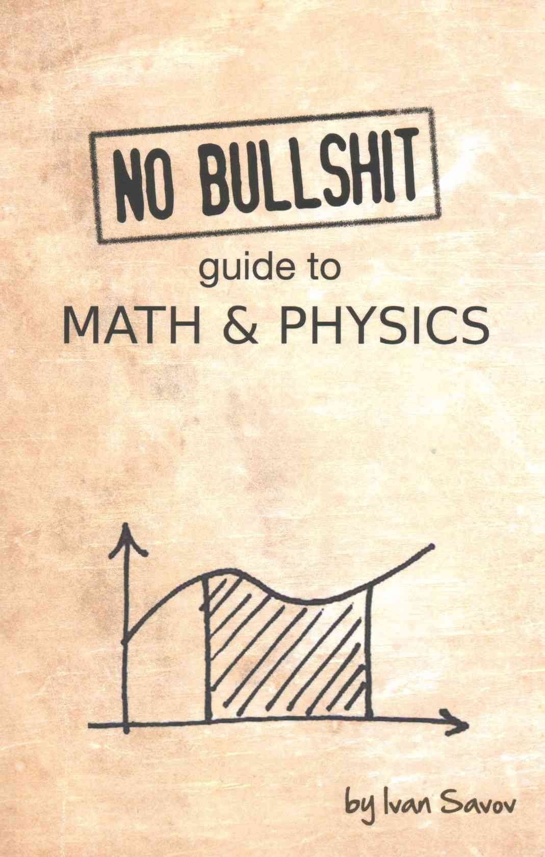

No Bullshit guide to Math & Physics

By Ivan Sayov

Often calculus and mechanics are taught as separate subjects. It shouldn't be like that. Learning calculus without mechanics is incredibly boring. Learning mechanics without calculus is missing the point. This textbook integrates both subjects and highlights the profound connections between them.

This is the deal. Give me 350 pages of your attention, and I'll teach you everything you need to know about functions, limits, derivatives, integrals, vectors, forces, and accelerations. This book is the only math book you'll need for the first semester of undergraduate studies in science.